April 2nd, 2025

6654 S Road F

Ulysses, KS 67880

Dear New Homeowner,

We recently were informed by the previous owners of your home that they had sold the home to you and left the: ECR3702 WATER REFINER, HEALTHWAY AIR PURIFIER & HERO385 REVERSE OSMOSIS drinking water system with you.

If you could call me at (316) 265-6111 so that I can update the full file with your information and go over any product and maintenance information you need. If the equipment is not in your possession, we would also like to know that too. Any information would be very helpful. You can call or email me at [service.schedule@moorewatertreatment.com](mailto:Devon.torres@moorewatertreatment.com) if that is easier.

Sincerely,

Leigha Foster

Moore Water & Air

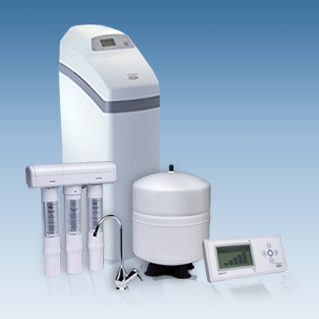

Check us out at [www.ecowaterofkansas.com](http://www.ecowaterofkansas.com)